## Appendix A - Description of test areas at Andøya

**RED** = Official test area **1**, **Bleik**

**Green** = Official test area **2**, **Grunnvatn**

**Blue** = Official test area **3**, **Stave**

## Important locations

Position A: N 69.2826°, Ø 15.9906° (Kirkegård) High power jamming

Position B: N 69.2801°, Ø 16.0062° (Laserveien/Ramnan) High power jamming and meaconing

Position C: N 69.2757°, Ø 15.9684° (Samfunnshuset) High power spoofing

Position D: N 69.2225°, Ø 15.9335° (Grunnvatn) "Sand box", low power jammers

Position E: N 69.1572°, Ø 15.8005° (Skogvollvatnet)

Position F: N 69.1440°, Ø 15.7585° (Nordmela) Southern end-point for mobile low power jammers

## Description of site 2

Location 2 is the parking lot at the end of a dirt road. Position N 69.2225°, Ø 15.9335°

Most of the testing will be conducted at the parking lot, or the surrounding area.

There will be certain marked position surrounding the area. 120 degrees apart, at 50, 100 and 150 meter in distance. Those positions can be found on the picture below:

## Description of motorcade route(s) on Andøya, site 3

The start is as Stave commynity house (69.212187 North ,15.858559 East), the small jammers can be used the intersection between county road 7702 and communal road “Oklveien” (69.14409 North, 15.75847 East). The picture below shows the stretch of road that can be used for the motorcade (Red line).

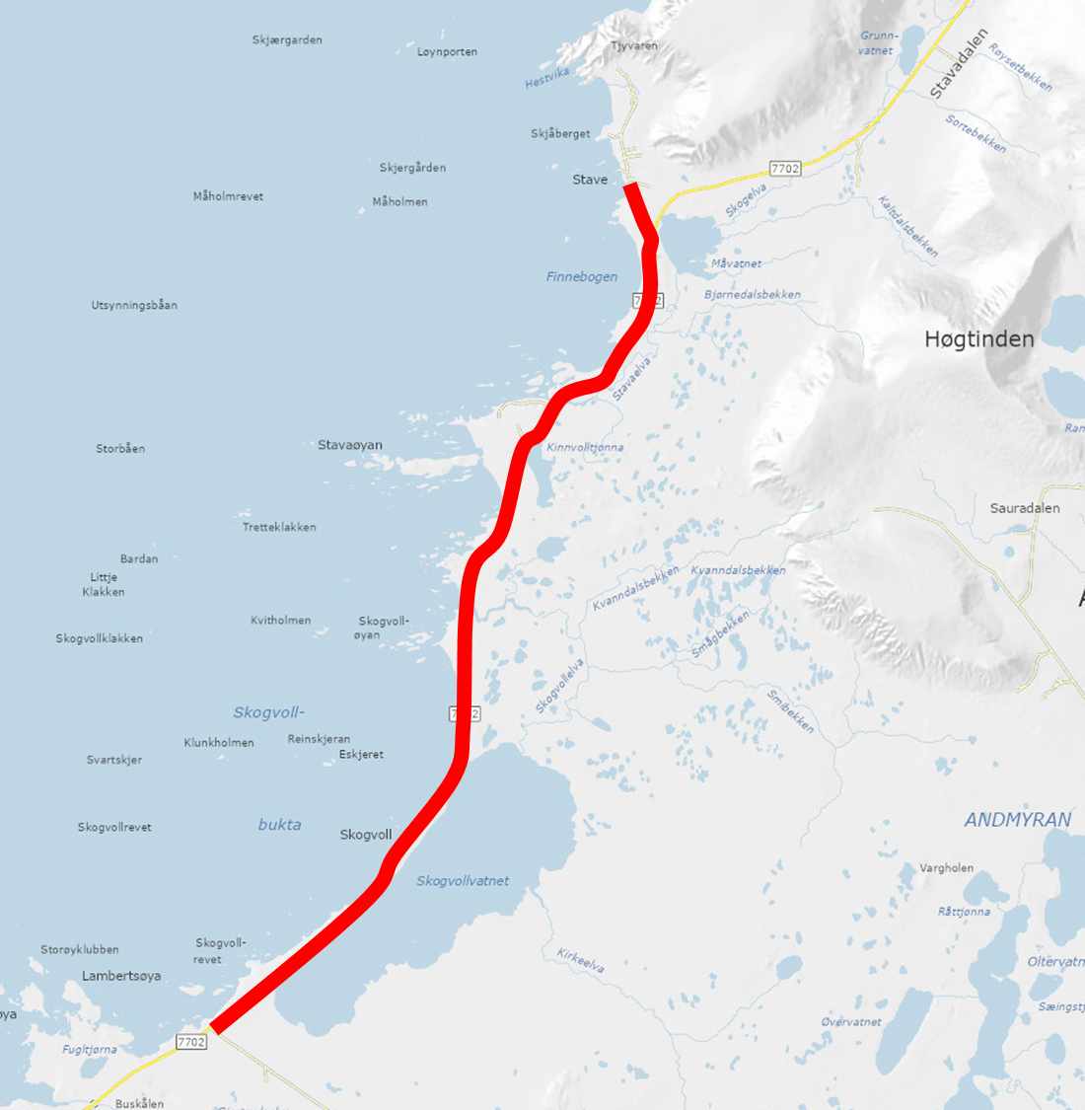

The road is quite narrow 5.1 meters with a speed limit of 80 km/h. The traffic volume is low with about 1000 vehicles per day. For some tests where reduced speed is need there will be a NPRA vehicle in front and at the back of motorcade. Communication to the vehicles will be via FM radio.